**ATIVIDADE FRANCISLEY FERNANDES DE SOUZA**

**Semáforo**

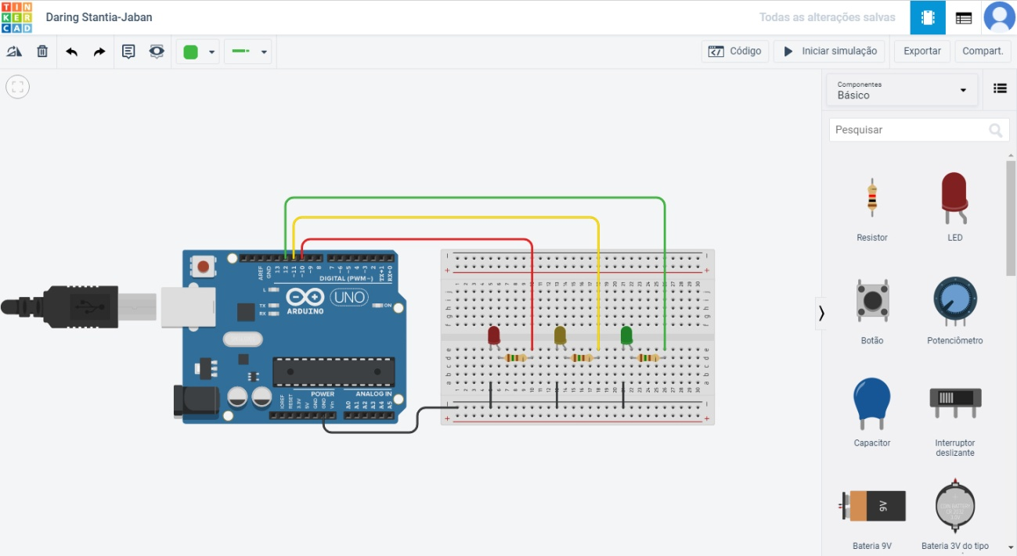

void setup() {

pinMode(12, OUTPUT);

pinMode(11, OUTPUT);

pinMode(10, OUTPUT);

}

void loop() {

digitalWrite(10, HIGH);

delay(3000); // Wait for 1000 millisecond(s)

digitalWrite(10, LOW);

digitalWrite(11, HIGH);

delay(1500);

digitalWrite(11, LOW);

digitalWrite(12, HIGH);

delay(3000);

digitalWrite(12, LOW);

}

**PiAno com Led**

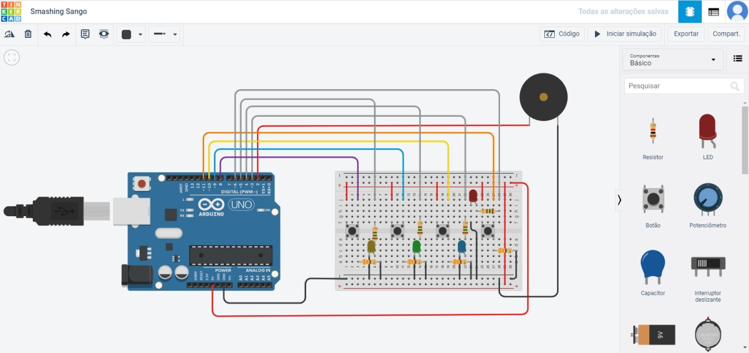

const int ledVermelho = 6;

const int ledAmarelo = 5;

const int ledVerde = 4;

const int ledAzul = 3;

const int btn1 = 8;

const int btn2 = 9;

const int btn3 = 10;

const int btn4 = 11;

const int tom = 2;

void setup() {

pinMode(ledVermelho, OUTPUT);

pinMode(ledAmarelo, OUTPUT);

pinMode(ledVerde, OUTPUT);

pinMode(ledAzul, OUTPUT);

pinMode(tom, OUTPUT);

pinMode(btn1, INPUT);

pinMode(btn2, INPUT);

pinMode(btn3, INPUT);

pinMode(btn4, INPUT);

}

void loop() {

if (digitalRead(btn1) == HIGH) {

tone (tom, 1000, 1000);

digitalWrite(ledVermelho, HIGH);

digitalWrite(ledAmarelo, LOW);

digitalWrite(ledVerde, LOW);

digitalWrite(ledAzul, LOW);

}

if (digitalRead(btn2) == HIGH) {

tone (tom, 1500, 1000);

digitalWrite(ledVermelho, LOW);

digitalWrite(ledAmarelo, HIGH);

digitalWrite(ledVerde, LOW);

digitalWrite(ledAzul, LOW);

}

if (digitalRead(btn3) == HIGH) {

tone (tom, 2000, 1000);

digitalWrite(ledVermelho, LOW);

digitalWrite(ledAmarelo, LOW);

digitalWrite(ledVerde, HIGH);

digitalWrite(ledAzul, LOW);

}

if (digitalRead(btn4) == HIGH) {

tone (tom, 2500, 1000);

digitalWrite(ledVermelho, LOW);

digitalWrite(ledAmarelo, LOW);

digitalWrite(ledVerde, LOW);

digitalWrite(ledAzul, HIGH);

}

}